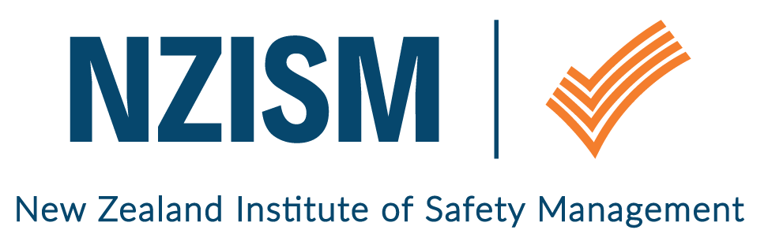
Wellington Branch

January 2019 Newsletter

Review of last event | The final event of the year on 4 December 2018 at The National Library was well attended. There was a positive buzz amongst members as they caught up with each other and shared notes on all things health and safety. Thanks to Greg Dearsly, NZISM President, who dropped in to give an update from NEC and wish everyone well for the Christmas break.
February event  The National Library  70 Molesworth Street  Wellington | Tuesday 5 February  Following on from his recent presentation to the Hutt Valley Employers’ Group, NZISM Wellington Branch is delighted to have Michael Jones as our first speaker for 2019. The topic of Michael’s presentation is “Knowing your risk management landscape” – a critical piece of the puzzle for H&S people. We’re looking forward to hearing from Michael.  12:00pm – 12:15pm: Doors open, arrival and networking  12:15pm – 1.00pm: Speaker begins  1.00pm – 1.15pm: Networking  1.30pm: Doors close  Please rsvp via Eventbrite for this event.  Biography: Michael Jones  Michael has over 30 years’ experience in health, safety and environmental management, working in a wide range of international and national industries including chemical, petroleum, energy distribution, construction, manufacturing, rail transportation and is currently working as a HSE consultant.  Experienced in risk assessment methodologies, management systems, behavioural based safety practices, and assessment programmes, Michael has broad experience in applying practical health, safety and environmental solutions to assist businesses focus on key strategic health, safety and environmental initiatives.  Michael holds a Post Graduate Diploma in Occupational and Safety, and a Bachelor of Science (Chemistry).  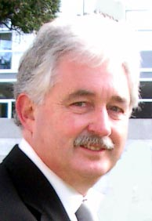
Bring a guest
Members are encouraged to bring along guests to the monthly seminars. Whilst there is a preference to translate the visits to membership, our focus is on growing risk management awareness amongst a cross section of people. Safety is everyone’s responsibility – not just the H&S professional.
Local H&S scene / What’s going on | Have you or your organisation done an activity recently that you’d like to share with other members? We welcome your input which can be supported by photos of the event if you wish. Please email us at well.nzism@gmail.com.  Can you help WorkSafe?  In 2018 WorkSafe commenced a programme aimed at raising awareness of noise as a work related health risk with the aim of changing behaviours. The programme is primarily aimed at managing the risk by good design of plant, structures and work place. To support the guidance material that is being developed WorkSafe are looking for examples of good practice that they can profile as case studies. Businesses should have had competent exposure surveys completed, made engineering changes, and have, or can verify the reduction in noise exposure with follow up monitoring.  If you are aware of anyone within your membership whose employers or clients have excellent examples of noise management in action they can contact the WorkSafe Project Delivery Specialist listed below and potentially profile their organisation and the work that is being done.  Iona Carlyle  Project Delivery Specialist  Engagement and Implementation Team  P +64 4 901 8539  E iona.carlyle@worksafe.govt.nz  Temporary Works: Risk and Awareness  Some of you will recall the update last year from Maurie Rohloff of Fletcher Construction, regarding the Temporary Works Forum. For those of you keen to find out more about how to manage the associated risks of temporary works, Engineering New Zealand have released details, dates and venues for Temporary Works Risk and Awareness courses in 2019.  https://www.engineeringnz.org/courses-events/event-template/?eventtemplate=259-temporary-works-risk-and-awareness-1896&region=IPENZC  Webinar: Managing the complexity of Overlapping Duties – 29 January 2019, 7.00pm – 8.00pm  Certified NZISM member and Chair of the NZISM Advisory Board Mike Cosman takes a look at the complexity of managing overlapping duties under the Health and Safety at Work Act 2015. The days of top down management of health and safety have been replaced with new obligations to manage up, down and sideways in many instances. Mike will be exploring the opportunities available to PCBUs to rethink their current ‘contractor management’ strategies by drawing on his growing base of experience providing advice under the new Act.  Please register via the NZISM website https://www.nzism.org/book/Sb2FCJJdEj9uDrGYPCXh4s2O/  If you’d like to promote an event or share information that would be of interest to NZISM members, please email well.nzism@gmail.com.
NZISM on LinkedIn | You may have seen this in Selena Armstrong’s newsletter prior to Christmas, but just in case you missed it…  Social media marketing is going to be a key channel in the 2019 Marketing Communications Plan for NZISM. As of 1 December 2018, the NZISM LinkedIn page changed from an unlisted group to a public page. This means it’s visible in search results and health and safety professionals will be able to link to NZISM and benefit from regular industry updates and the latest news on events and conferences.  Please share the link / invite friends or colleagues who would benefit from being LinkedIn with NZISM.
Other Information | Contact information  A reminder to ensure your profile on the NZISM website – https://www.nzism.org is up to date. The success of the Wellington branch relies on the input of its members and our ability to send communications to you.
Important stuff to know | Wellington monthly events are scheduled for the first Tuesday of every month at The National Library, Thorndon. Keep an eye on the NZISM Calendar on the website for more information.  A reminder also, to check out our neighbouring Regions events on the NZISM Calendar. There may be something on in another Branch that is relevant to you.

